Unit 2.4 Classical China: Dynastic Cycle

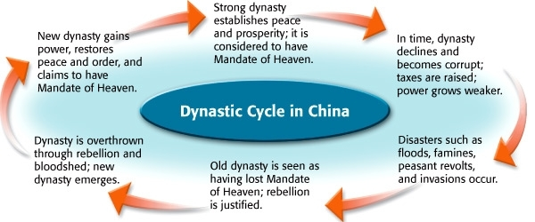
Signs you’ve lost the Mandate:

MANDATE OF HEAVEN:

