Name: _______________________________________________________ Period: _________

Worker Conditions in the Early 19th Century

Document A: Miner Betty Harris, 37, gave testimony to an 1842 Royal Commission investigating conditions in British Mines
I was married at 23, and went into a colliery [coal mine and its connected buildings] when I was married. I can neither read nor write…I am a drawer [worker who pulled coal tubs in a mine; tubs were attached to the drawer’s belt with a chain], and work from 6 in the morning to 6 at night. Stop about an hour at noon to eat my dinner; have bread and butter for dinner; I get no drink…
I have a belt around my waist, and a chain passing between my legs, and I go on my hands and feet. The road is very steep, and we have to hold by a rope; and when there is no rope, by anything we can catch hold of. There are six women and about six boys and girls in the pit I work in; it is very hard work for a woman. The pit is very wet where I work, and the water comes over our clog-tops always, and I have seen it up to my thighs; it rains in at the roof terribly. My clothes are wet through almost all day long…
My cousin looks after my children in the day time. I am very tired when I get home at night; I fall asleep sometimes before I get washed…the belt and chain is worse when we are in the family way [pregnant]. My feller (husband) has beaten me many a times for not being ready.

Document B: German socialist Friedrich Engels, co-founder of Marxism, described industrial Manchester in his book, The Condition of the Working-Class in England in 1844
The first court below Ducie Bridge…was in such a state at the time of the cholera that the sanitary police ordered it evacuated, swept, and disinfected with chloride of lime [bleaching powder]…At the bottom flows, or rather stagnates, the Irk, a narrow, coal-black, foul smelling stream, full of debris and refuse, which it deposits on the shallower right bank…
Above the bridge are tanneries [buildings where skins and hides are tanned], bone mills [mills that convert animal bones into fertilizer] and gasworks, from which all drains and refuse find their way into the Irk, which receives further the contents of all the neighboring sewers and privies [outhouses]…Below the bridge you look upon the piles of debris, the refuse, the filth, and offal from the courts on the steep left bank; here each house is packed close behind its neighbor and a piece of each is visible, all black, smoky, crumbling, ancient, with broken panes and window frames…
Such is the Old Town of Manchester…in defiance of all considerations of cleanliness, ventilation, and health which characterize the construction of this single district, containing at least twenty to thirty thousand inhabitants.

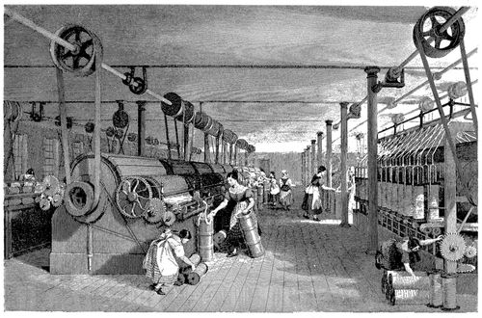
Document C: The picture on the right is a print of a cotton mill that appears in the book History of the Cotton Manufacture in Great Britain (London, 1835), by Edward Baines. The image shows the belts that connected the machines to a pulley system. A steam engine rotated the wheels on the shaft to power the machines. Note how close the female workers’ hands, hair, and clothing are to the rotating gears.

Task: Answer the following questions based on the primary sources provided

- Looking at Document A, How many hours did Betty Harris work each day?

- What is a drawer, according to Document A?

- Why do you think the women and children were the drawers in the mine?

- Looking at Document B, how might a description of the city of Manchester written by a factory owner contrast from that written by Engels?

- What is the “Irk”?

- According to Engels, what is the effect of industrialization on people and towns?

- Looking at Document C, how does Baines depict the working environment in the cotton mill? Is it safe or dangerous?

- Is Document C a useful historical record? Explain.

- Looking at Documents A & C, what do Harris’s testimony and the Baines print suggest about how the work experience for women in mines and cotton mills was similar and different?

- How could Engels have used Harris’s testimony to support his main point about industrialization?

